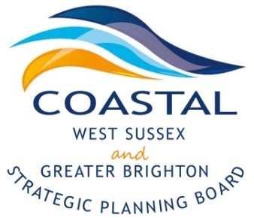
Coastal West Sussex & Greater Brighton Strategic Planning Board

Agenda

Monday, 13th July 2015
2-4pm

Council Chambers, Adur Civic Centre
Ham Road
Shoreham By Sea
BN43 6PA

2.00pm | Welcome and Introductions  - Minutes of the meeting and any matters arising | Cllr Ricky Bower  Karl Roberts
 | - Election of a new Chairman at the October meeting
 | - Request from Horsham to join the SPB
2.15pm | NLP Reports for noting | Karl Roberts/Caroline Wood
Close of Formal Meeting
2.20pm | Workshop – Refresh of the Local Strategic Statement | Catriona Riddell
3.50pm | AOB, summary of actions and close  - Ed Vaizeys letter - attached | Cllr Bower

Future meeting dates-

2015

- October 12th 2-4pm Worthing Town Hall- Gordon Room

2016

- 18th January 2016
- 18th April 2016
- 18th July 2016
- 17th October 2016

