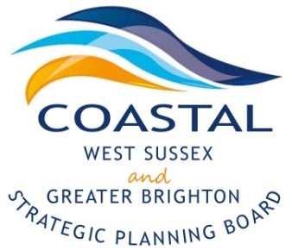
Coastal West Sussex & Greater Brighton Strategic Planning Board

Agenda

Monday, 18th April 2016
2-4pm

The Council Chamber
The Shoreham Centre,
Pond Road, Shoreham-by-Sea, West Sussex, BN43 5WU

2.00pm | Welcome and Introductions  - Notes from the last meeting  - Signing the refreshed Local Strategic Statement | Cllr Bryan Turner
2.10pm | An update of transport investment across the area | Peter Philips,  Highways England
2.35pm | Growth Plan for West Sussex | Duncan Barrett,  West Sussex County Council
2.50pm | Local Strategic Statement – options for review | Catriona Riddell
3.45pm | Any other business, summary of actions and close | Cllr Bryan Turner

Future meeting dates for 2016

- 18th July 2016 – The Shoreham Centre

- 17th October 2016 – The Gordon Room, Worthing Town Hall

