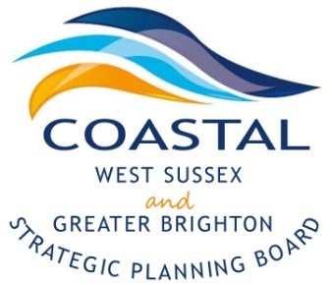
Coastal West Sussex & Greater Brighton Strategic Planning Board

Agenda

Monday, 12th January 2014
2-4pm

Council Chambers, Adur Civic Centre
Ham Road
Shoreham By Sea
BN43 6PA

2.00pm | Welcome and Introductions  - Minutes of the meeting and any matters arising | Cllr Ricky Bower
2.10pm | Update:  - Terms of Reference and Memorandum of Understanding  - Transparency  - Strategic Planning Adviser post | Karl Roberts, Arun DC
2.20pm | Highways Agency – an update on the organisation and specific schemes in the CWS and Gtr Brighton area | Peter Phillips, HA
2.45pm | Commission to create the background evidence papers – an opportunity for consultation | Ciaran Gunne-Jones and colleagues  NLP
3.50pm | AOB, Summary of actions and close | Cllr Ricky Bower

Future meeting dates-

- April 13th 2-4pm Worthing Town Hall- Gordon Room

- July 13th 2-4pm Adur Civic Centre- Council Chambers

- October 12th 2-4pm Worthing Town Hall- Gordon Room

