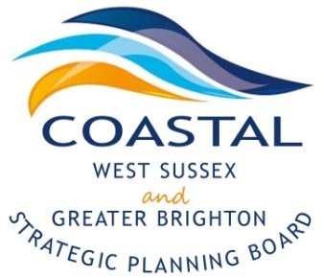
Coastal West Sussex & Greater Brighton Strategic Planning Board

Agenda

Monday, 12th October 2015
2-4pm

The Gordon Room
Worthing Town Hall
Chapel Road
Worthing
BN11 1HA

2.00pm | Welcome and Introductions | Cllr Ricky Bower  Karl Roberts
 | - Election of a new Chairman
 | - Minutes of the previous meeting and any matters arising
2.15pm | Devolution proposals – verbal update | Caroline Wood/Karl Roberts
2.20pm | Workshop 2 – The refresh of the Local Strategic Statement | Catriona Riddell
3.50pm | AOB, summary of actions and close | Cllr Bower

Future meeting dates-

10.00 – 12 00 Thursday, 12th November 2015 – Wider Stakeholder workshop in The Gordon Room, Worthing Town Hall.

2016

- 18th January 2016
- 18th April 2016
- 18th July 2016
- 17th October 2016

