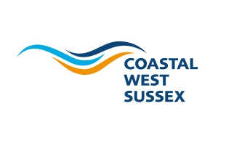
August 2021

Coastal West Sussex Partnership
Terms of Reference

1 Introduction

  - The Coastal West Sussex Partnership brings together stakeholders around key economic issues that affect the coastal strip of West Sussex from Selsey and Chichester in the west through to Shoreham in the east.

  - It is the recognised economic partnership for the Coastal West Sussex sub-region and aims to provide strong public and private sector leadership on larger than local issues that impact on the coastal economy.

  - The Partnership’s vision is for a strengthened coastal economy that delivers an exceptional experience for residents, businesses and visitors. Our future includes a better skilled workforce, a better-connected coast and better employment & job opportunities.

2. Role of the Partnership

2.1 The CWS Partnership cannot deliver change on its own but it can use its collaborative strength, talents and knowledge to take action where it can make a difference to the local economy. The CWS Partnership offers a business perspective to influence, coordinate, lobby, broker, promote and lead in ways that may sometimes be more difficult for individual local authorities.

  - The Coastal West Sussex Partnership has a Board that meets up to four times a year and is the voice of coastal West Sussex, championing economic growth, influencing political strategy and investment decisions through collaboration between the public and private sector. The Board has a key role in promoting economic growth and business development across the coastal areas of Adur, Arun, Worthing and Chichester: The CWS Partnership Board will:

- Coordinate activity between its constituent local authorities and enable them to have a greater collective voice on issues of mutual concern
- Provide a forum for business to influence public policy and investment decisions on issues that impact on business and economic performance
- Be an important vehicle for setting local economic development priorities
- Work with Coast to Capital to influence investment decisions and support delivery of its Business Plan.
- Represent the Coastal West Sussex area on other Boards or Forums – e.g. Greater Brighton Economic Board

3 Governance

  - CWSP is one of three spatial partnerships in West Sussex and it has an informal relationship with Coast to Capital, the Local Enterprise Partnership
3.2 CWSP will work with other groups and partnerships to achieve the vision and goals for the coast and we will establish and support new groups where needed. The diagram below shows the relationship between the Coastal West Sussex Partnership and the wider economic development structures across the Coast to Capital area.

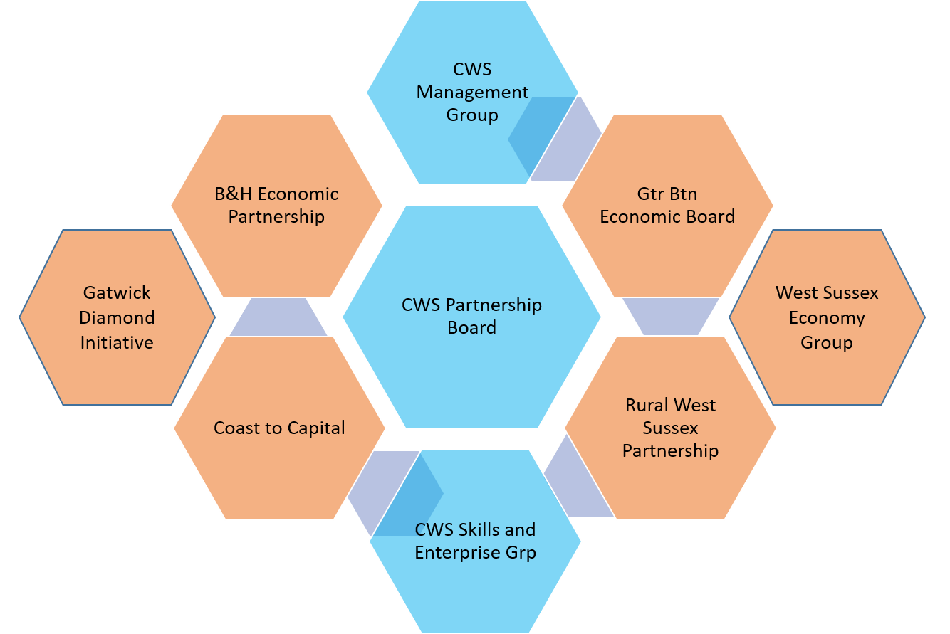

  - The Partnership will have non-statutory but executive status.

4 Membership of the CWS Partnership Board

4.1 One Councillor nomination from each of the Local Planning Authorities:
- Adur District Council
- Arun District Council
- Chichester District Council
- West Sussex County Council
- Worthing Borough Council

4.2 Members must nominate a substitute to attend meetings and act on their behalf if necessary.

4.3 The CWS Partnership Board will strive to be a business led and business focussed partnership; to champion the economic priorities for the coast and where possible, align with the economic priorities of Coast to Capital, the Local Enterprise Partnership. The CWS Partnership Board has secured and will continue to seek representation from a range of coastal businesses representing various industry sectors across CWS.

4.4 The Board is also represented by the following:
- Higher education sector (one nomination)
- Further education ( one nominations)
- Business Representative Organisations (Institute of Directors, Chambers of Commerce, FSB etc.)

  - The Board will be advised of any proposed nominations received and in the absence of any objections, the secretariat will invite the nominee to join the Board.
  - Officers from all of the Local Planning Authorities will also be invited to attend the Partnership Board.

5 CWS Partnership Board meetings

  - Meetings of the Board will be held no more than quarterly or as may be agreed for the efficient conduct of business. No more than four full Board meeting will be held each calendar year.

  - The Chairman may agree, when relevant to the business of the meeting, to invite further advisers to attend and may invite them to address the meeting when appropriate.

6 Chairman and Vice Chairman of the CWS Partnership Board

6.1 The Chairman and Vice Chairman shall be elected from the business representatives on the CWS Board and undertake a maximum period of three years in post but may stand for re-election. A Vice Chairman will also be elected to act when needed.

6.2 Should the Chairman or Vice Chairman cease to be members of the Partnership Board then an election will be held.

6.3 Nominations for Chairman and Vice Chairman will be sought two months in advance of the elections and will be submitted for proposal and seconded at the subsequent meeting. Members of the Partnership Board may put themselves forward or may propose others, on the understanding that the proposee has agreed to stand.

6.4 Should a Chair or Vice Chair vacate their post during their term of office an extra election will take place with 28 days’ notice to all Partners, following the same procedure as for tri-annual elections.

7 Voting

7.1 The nature of the Partnership means that the membership should remain flexible to reflect the business led nature of engagement and all attending members will be entitled to vote.

7.2 The Partnership will take decisions by consensus. If there is no agreement the Chairman may have to request that a vote is taken. The Chairman will call for a vote to be taken, with a decision being taken by simple majority. The Chairman has the casting vote in the event of an equal number of votes being cast for or against a proposal.

Reporting and Information

  - An agenda and supporting papers for each Partnership Board meeting and any subcommittee meetings will be circulated no less than five working days prior to each meeting

  - Information will be circulated, where possible, electronically to all Board members.

  - Any member of the Partnership may propose an item for the agenda by contacting the Director or Chairman of the CWS Partnership at least two weeks in advance of a meeting.

  - ‘Any other business’ items are asked to be notified to the Director at least three working days in advance of a meeting. ‘Any other business items’ which have not been submitted in advance will only be added at the discretion of the Chairman.

- Coastal West Sussex Director

9.1 A Coastal West Sussex Director will drive forward the work programme of the Partnership Board and associated groups. This post will be line-managed by the Chief Executive of Adur & Worthing Borough Council as the employing authority but will report to the Chairman and CWS Management Group as appropriate.

10 Task Groups

10.1 The Partnership Board can appoint task groups for any purpose that will assist with the delivery of the CWS priorities. The membership of these groups need not be limited to the membership of the Partnership Board but may be drawn from other organisations, partnerships, agencies and experts in appropriate disciplines. At least one board member/agreed substitute will sit on any task group set up by the Partnership Board.

10.2 The terms of reference of each task group will be clearly determined at the time of appointment. Any task group established will report back to the Partnership Board.

11 Conflicts of Interest

11.1 Members of the CWS Board should declare any conflicts of interest against agenda items at the meetings should they occur.

11.2 All Partnership members must declare to the Board in advance, any direct or indirect interest, which may arise in respect of a contract or other matter to which the Partnership is, or may become, involved.

11.3 Where a conflict of interest is declared, the relevant Partnership member shall not influence any decision on the matter, they may remain in the meeting and provide information and answer questions as required but may not vote on the matter under discussion.

